Table of Contents…

Product/Sku Visibility
Making products show/not show on your website
Making individual SKUs show/not show on your website
Categories
How to Add a product to a category
How to Remove a product from a category
Pricing
Making price changes at the Product Level
Making price changes for multiple Skus
Making price changes for a specific Sku

Making products show/not show on your website
Once your merchandise has been loaded to CMC, you can begin managing product and Sku visibility.
- After selecting a product or a listing of products (Finding General Merchandise Items in CMC) scroll to the right in the main work area to locate the Visible checkbox.
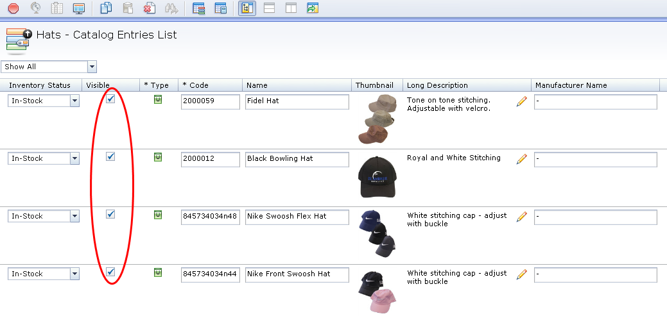
- To make the product visible on the website place a check in this column
- To make the product not visible on the website remove the check from this column.
- To make the changes take effect, click the Save icon in the tool bar. The product will change will take affect the next day.

Making individual SKUs show/not show on your website
Sometimes you will only sell out of a single size or color of a product and you will want to hide only the SKUs associated with those sizes and colors. Likewise if you receive a restock of an item you reactivate it on your website.
For a single Sku:
- Double click the product to access the Sku details page.
- Scroll down and open the Custom option.
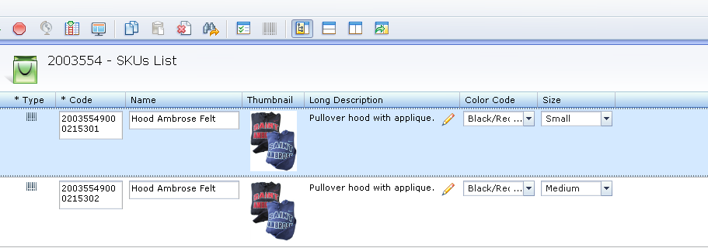
- To make the SKU visible on the website place a check in the visibility checkbox.
- To make the SKU not visible on the website remove the check from the visibility checkbox.
- To make the changes take effect, click the Save icon in the tool bar.
For multiple SKUs of the same product:
- After you have selected your specific product and it is visible in the main work area right click below the store name and select Show SKUs List.
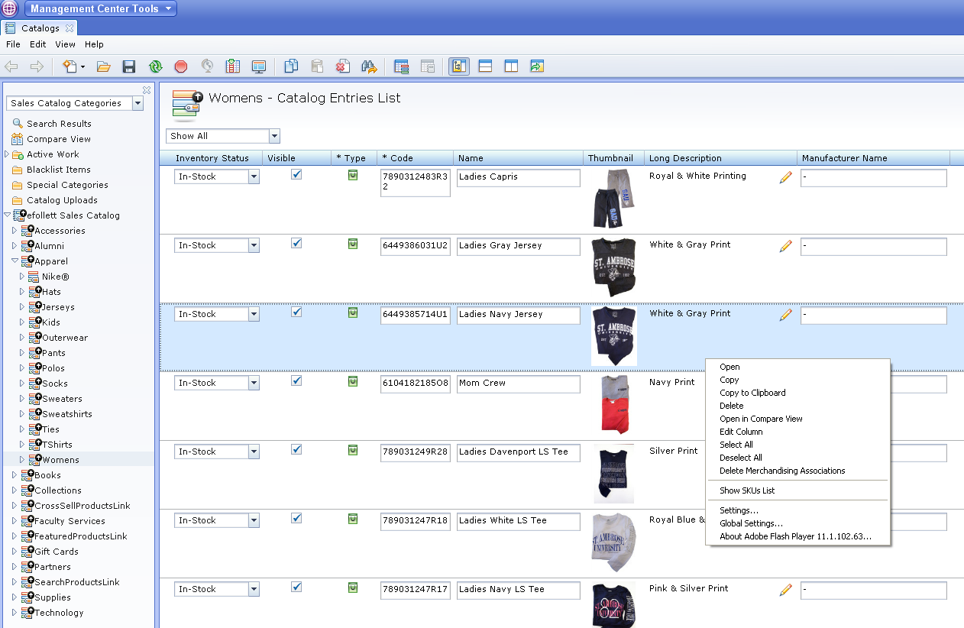
- Select the SKU and click on the Split Horizontally button
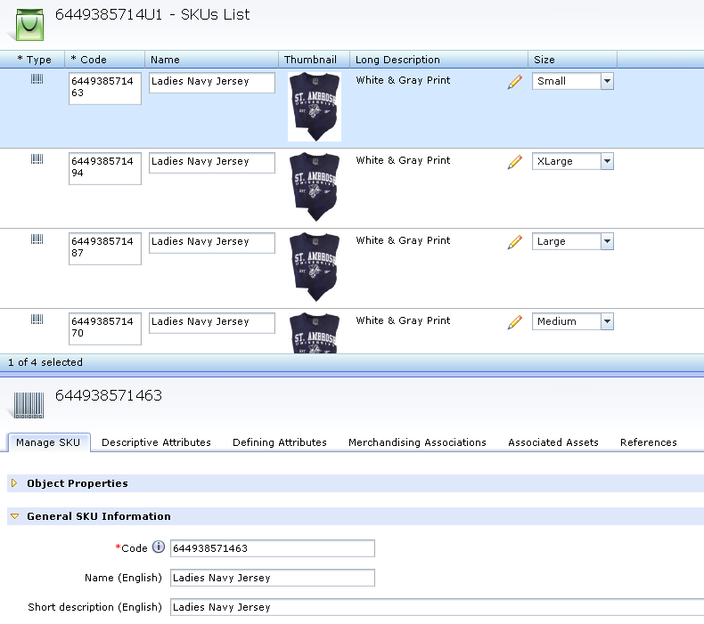
- On the bottom split screen, scroll down and open the Custom option.
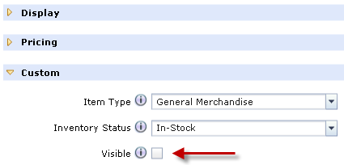
- To make the SKU visible on the website place a check in visibility checkbox.
- To make the SKU not visible on the website remove the check the visibility checkbox.
- To make the changes take effect, click the Save icon in the tool bar.
- Repeat for each SKU

Adding products to new categories:
- Enter in the Product Number of the item you wish to add and click Find.
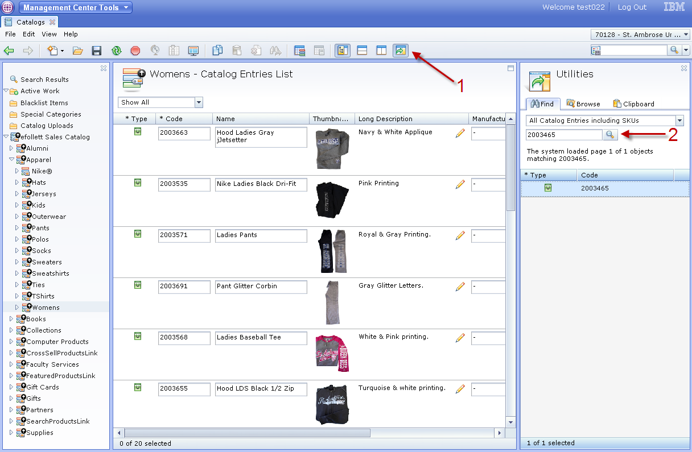
- Click and drag the product from the right hand Utilities window to the center category workspace.
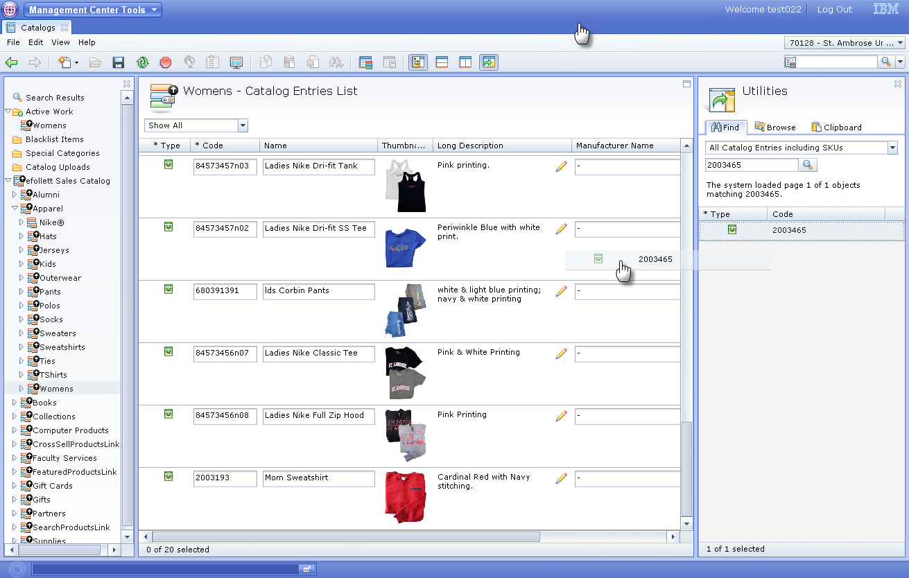
- The product you added will always be at the bottom and the change will be registered in Active Work.
- Click the Save icon to record the change.
How to Remove a product from a category
When you no longer want a product to be associated with a sub category please contact your eFollett Web Specialist with the name, product number, and the category it resides in so they can help you remove it.
Making price changes at the Product Level
- Find the Product Number of the item on the Search box and hit enter.
- Select Split Horizontal View.
- On the bottom screen, scroll down to Pricing. Click on the arrow to open.
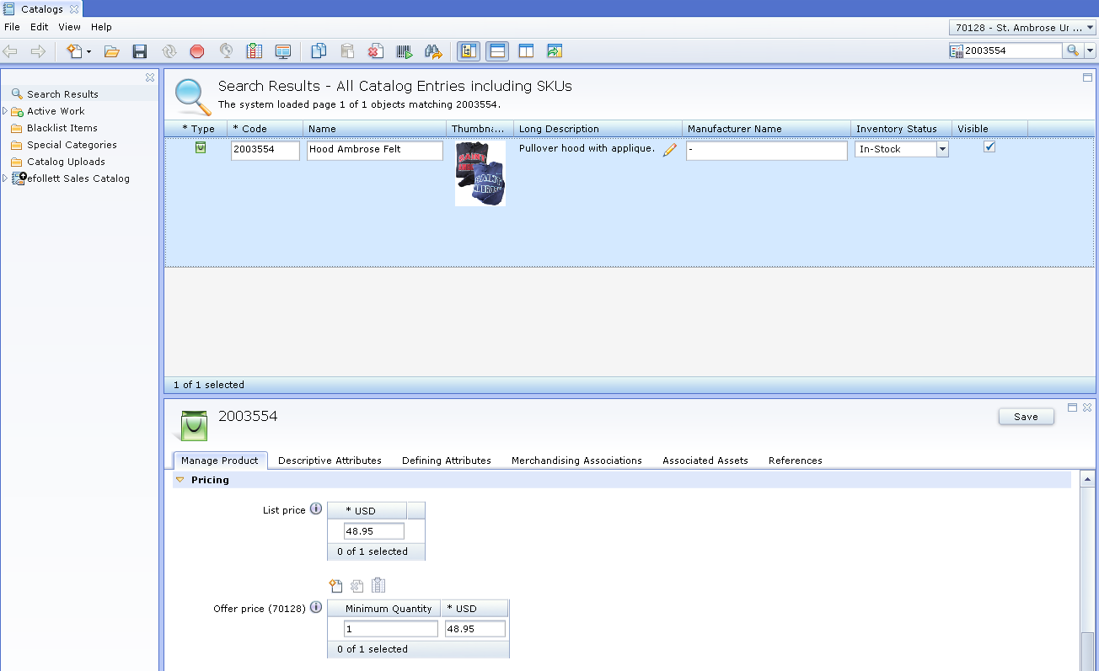
- To change the whole price of the product, enter the new price under the List Price box and the Offer Price box.
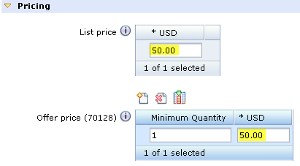
- For sale/clearance, change the Offer Price box only.
- Click the Save icon to record the change.
- Changes to a product must be made for each Sku associated with the product.
Making price changes for multiple Skus
- Find the Product Number of the item on the Search box and hit enter.
- Select Split Horizontal View.
- Select the product and right click and select Show Skus List
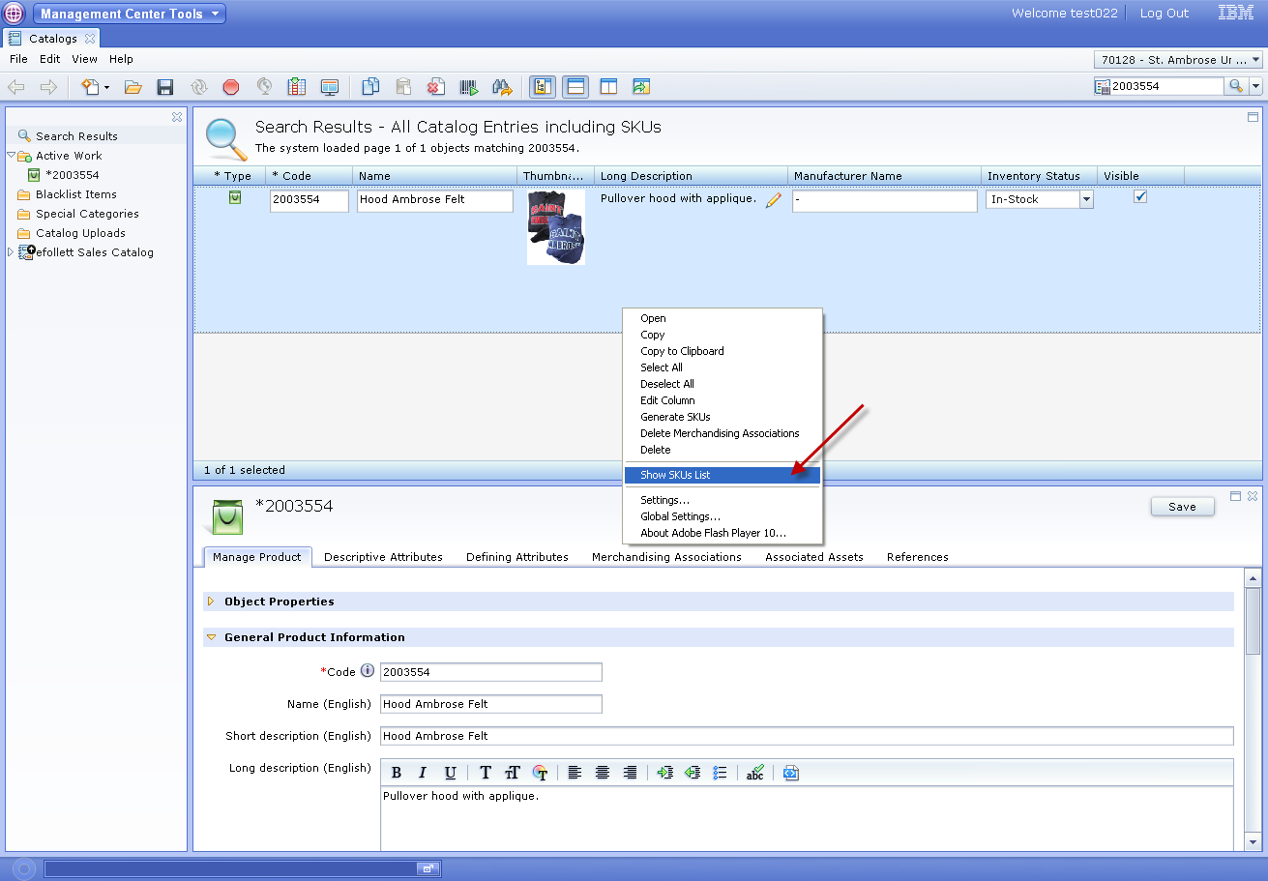
- Select a Sku and scroll down to Pricing on bottom screen. Click on the arrow to open.
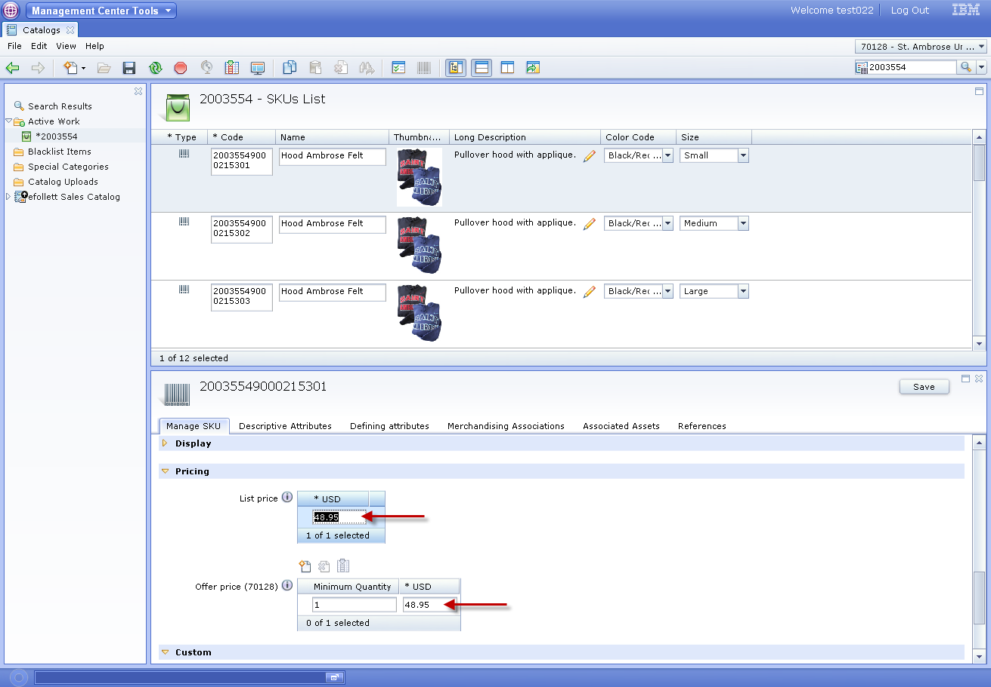
- Change List Price and Offer Price for the Sku to reflect the Product Level.
- Click the Save icon to record the change.
- Repeat for each Sku.
Making price changes for a specific Sku
- Find the Sku on the Search box and hit enter.
- Select a Sku and scroll down to Pricing on bottom screen. Click on the arrow to open.
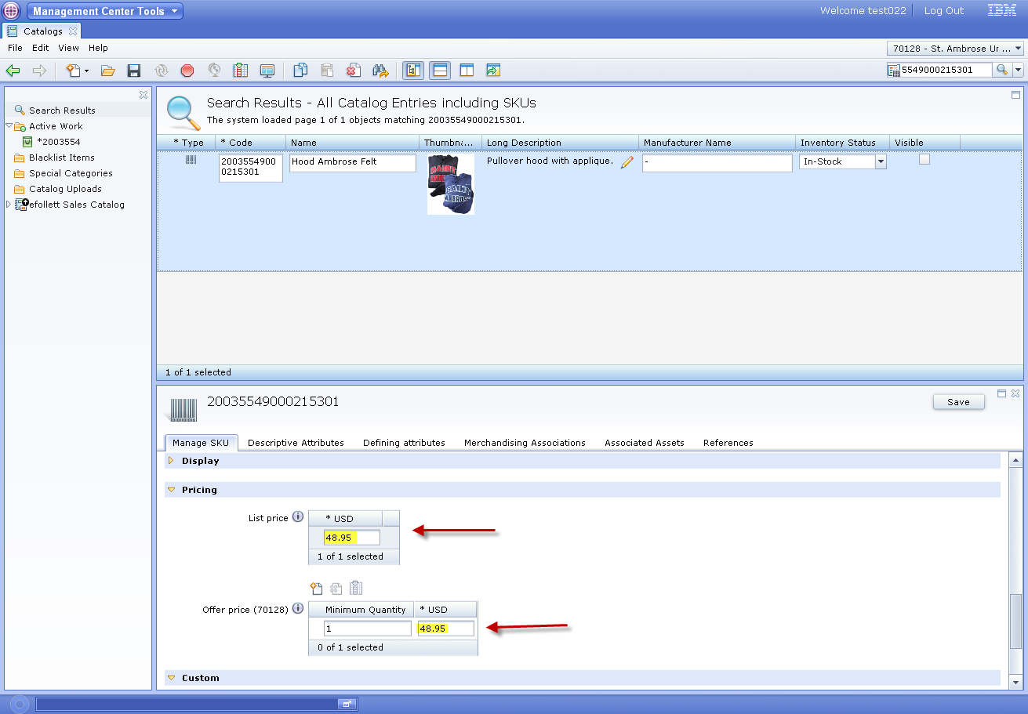
- Change both the List Price and Offer Price.
- Click the Save icon to record the change.

