Making price changes at the Product Level
- Enter the Product # of the item on the Search box and hit enter.
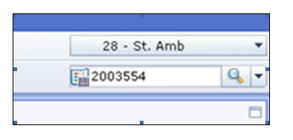
  - Product Number can be found on detail page of product:
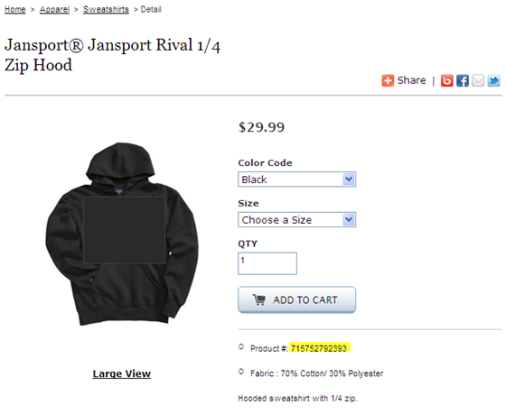
- Select Split Horizontal View
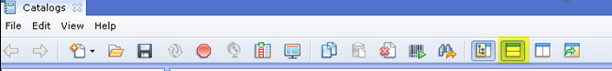
- On the bottom screen, scroll down to Pricing. Click on the arrow yellow arrow.
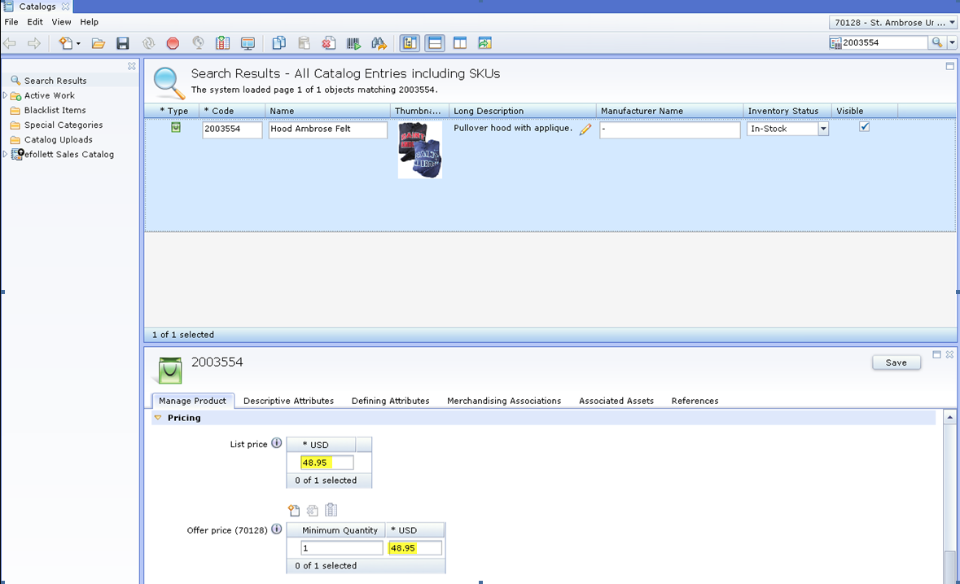
- To change the whole price of the product, enter the new price under the List Price box and the Offer Price box.
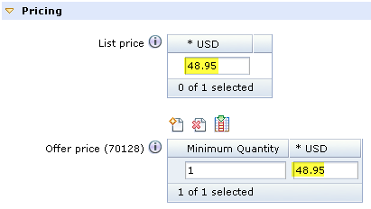
  - If Offer Price box is not showing
    - Click on
    - Minimum Quantity: 1
  - Please note: For Sale/Clearance, change the Offer Price box only.
- Click the Save icon to record the change.
- Changes to a product must be made for each Item Sku associated with the product
Making price changes for multiple Item Skus
- Enter the Product # of the item in the Search box and hit enter.
- Select Split Horizontal View
- Select the product, Right click and select Show Skus List
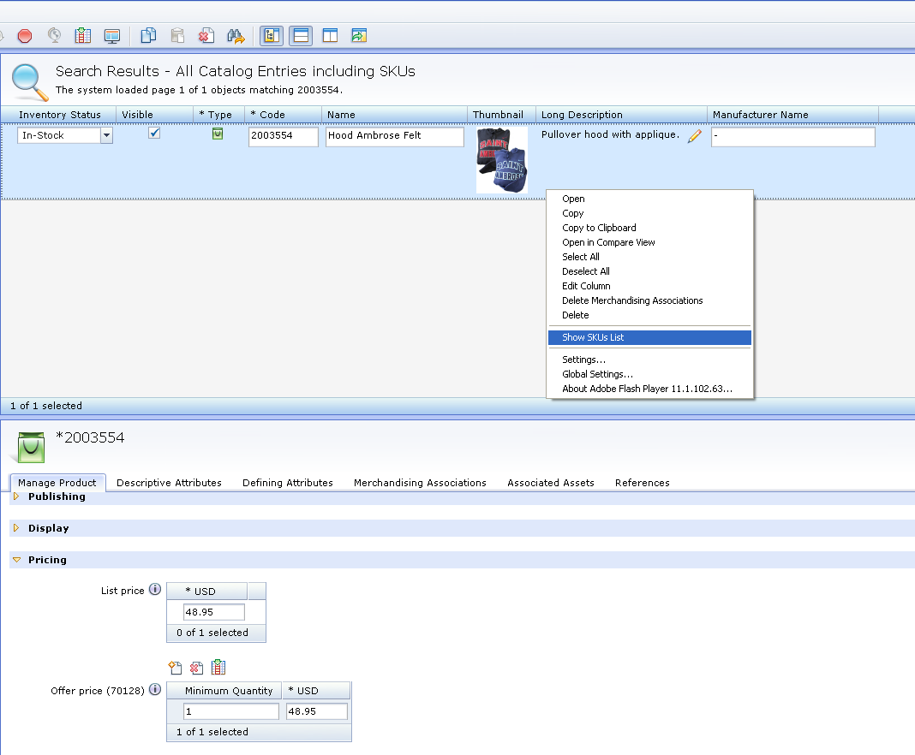
- Select an Item Sku and scroll down to Pricing on bottom screen. Click on the arrow yellow arrow.
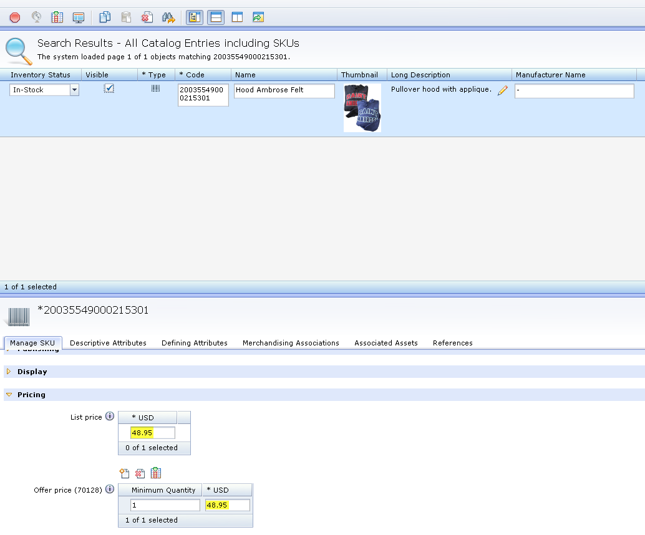
- Change List Price and Offer Price for the Item sku to reflect the Product Level.
- Click the Save icon to record the change.
- Repeat for each Item Sku.
Making price changes for a specific Item Sku
- Enter the Item Sku on the Search box and hit enter.
- Select an Item Sku and scroll down to Pricing on bottom screen. Click on the arrow to open.
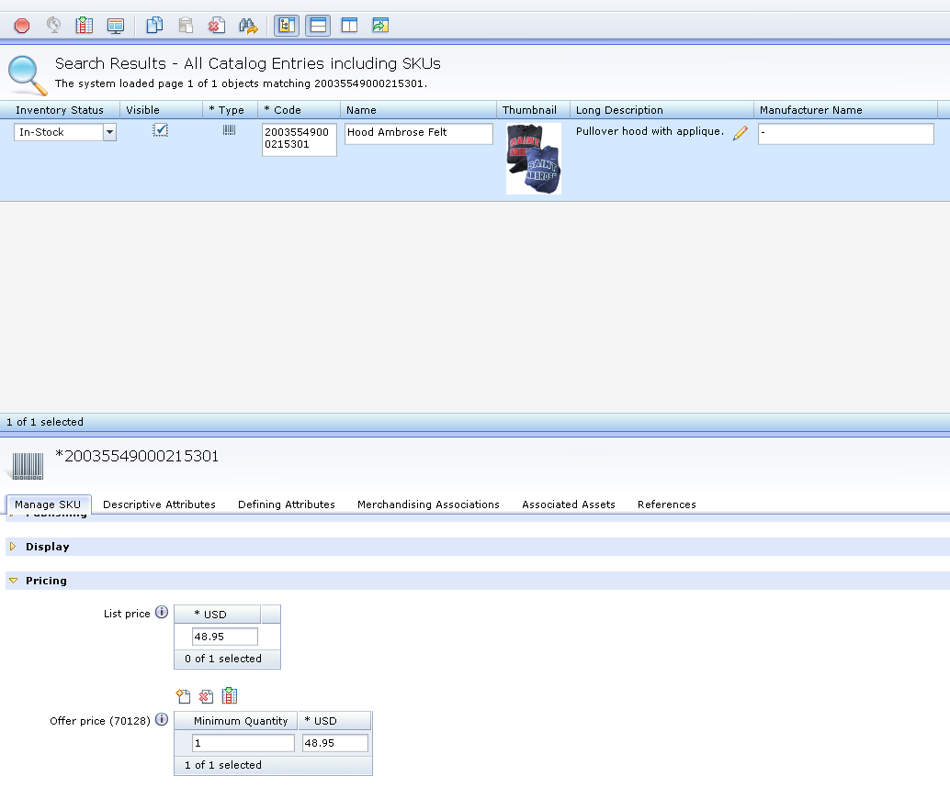
- Change both the List Price and Offer Price.
- Click the Save icon to record the change.

