Making products show/not show on your website
Once your merchandise has been loaded to CMC, you can begin managing product and Sku visibility.
- After selecting a product or a listing of products (Finding General Merchandise Items in CMC) scroll to the right in the main work area to locate the Visible checkbox.
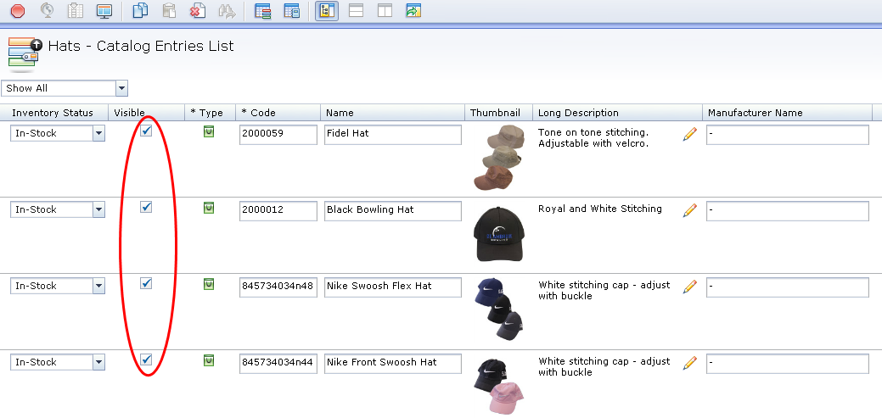
- To make the product visible on the website place a check in this column
- To make the product not visible on the website remove the check from this column.
- To make the changes take effect, click the Save icon in the tool bar. The product will change will take affect the next day.

Making individual SKUs show/not show on your website
Sometimes you will only sell out of a single size or color of a product and you will want to hide only the SKUs associated with those sizes and colors. Likewise if you receive a restock of an item you reactivate it on your website.
For a single Sku:
- Double click the product to access the Sku details page.
- Scroll down and open the Custom option.
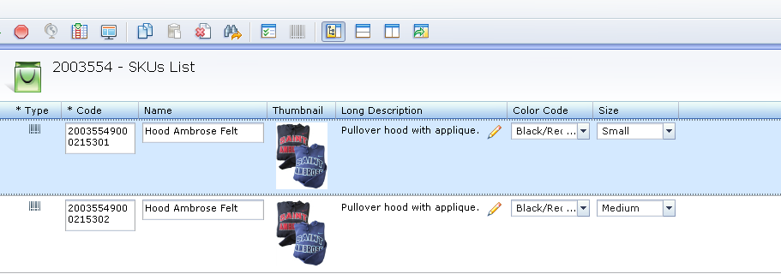
- To make the SKU visible on the website place a check in the visibility checkbox.
- To make the SKU not visible on the website remove the check from the visibility checkbox.
- To make the changes take effect, click the Save icon in the tool bar.
For multiple SKUs of the same product:
- After you have selected your specific product and it is visible in the main work area right click below the store name and select Show SKUs List.
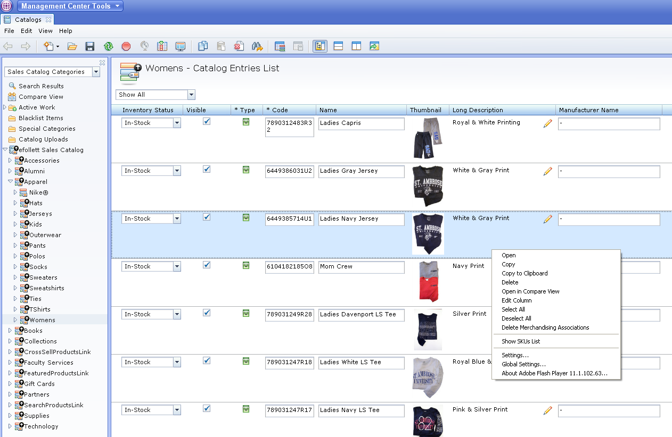
- Select the SKU and click on the Split Horizontally button
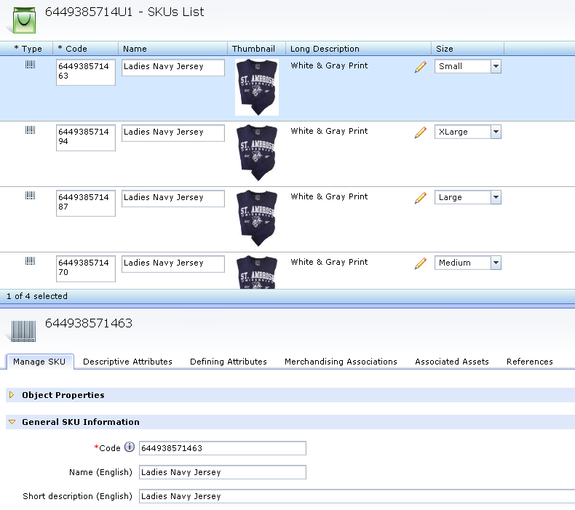
- On the bottom split screen, scroll down and open the Custom option.
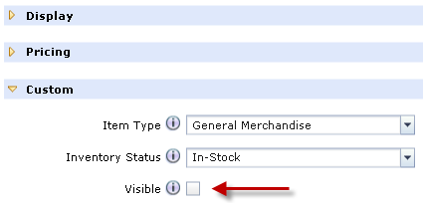
- To make the SKU visible on the website place a check in visibility checkbox.
- To make the SKU not visible on the website remove the check the visibility checkbox.
- To make the changes take effect, click the Save icon in the tool bar.
- Repeat for each SKU

